Customer Segmentation Analysis Report

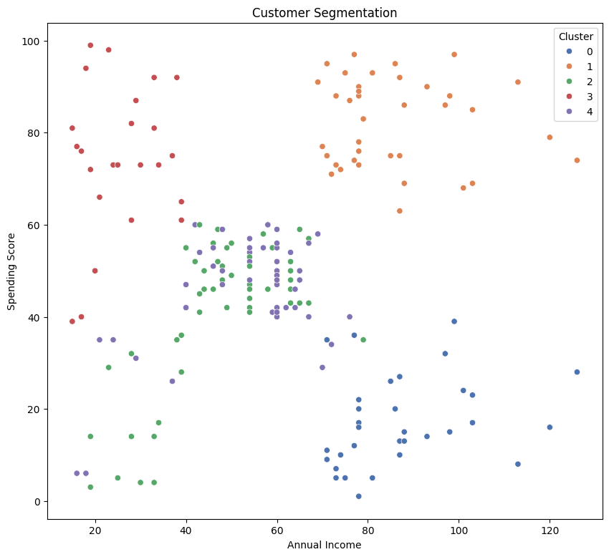

Fig.(1) : Cluster Segmentation of Mall Customers on the basis of Annual Income and Spending Score.

# Overview

This report analyzes customer segments based on their annual income and spending score, as visualized in the above scatter plot. Using K-means clustering, the customers have been divided into five distinct segments. Each segment exhibits unique characteristic that can inform targeted marketing strategies.

## Key Insights from the Clustering Result

1. Cluster 0 (Blue)

• I**ncome Range**: Medium to High ( ~ 70 - 140)

• **Spending Score**: Low to medium (~ 0 - 40)

• **Characteristics**: These customers have a wide range of annual incomes but generally exhibit lower spending scores.

• **Size**: Moderately populated

1. Cluster 1 (Orange)

• **Income Range**: Low to Medium (~ 20 - 80)

• **Spending Score**: Low to Medium (~ 0 - 60)

• **Characteristics**: These customers have lower annual incomes but are medium spenders.

• **Size**: Moderately populated

1. Cluster 2 (Green)

• **Income Range**: Low to Medium (~ 0 - 70)

• **Spending Score**: Medium (~ 0 - 60)

• **Characteristics**: These customers have low to moderate annual incomes and spending scores.

• **Size**: Moderately populated

1. Cluster 3 (Red)

• **Income Range**: Low (~ 0 - 50)

• **Spending Score**: High (~ 40 - 100)

• **Characteristics**: These customers have low annual incomes and high spending scores, indicating premium customers.

• **Size**: Moderately populated

1. Cluster 4 (Purple)

• **Income Range**: High (~ 70 - 140)

• **Spending Score**: High (~ 60 – 100)

• **Characteristics**: These customers have high annual incomes and high spending scores, indicating Premium Customers.

• **Size**: Densely populated

# Recommendations for Marketing

1. Cluster 0 (Medium to High Income, Low to Medium Spending)

Develop targeted campaigns and schemes promoting brand exclusivity and benefits of premium products. Offer exclusive deals to encourage higher spending.

1. Cluster 1 (Low to Medium Income, Low to Medium Spending)

A mixed marketing approach with budget friendly products for regular purchase, and premium products with the medium discounts and availability could benefit.

1. Cluster 2 (Medium Income, Medium Spending)

Can be Converted to Higher Spending range by targeted Campaigns with limited time offers and frequent promotions from premium brand.

1. Cluster 3 (Medium Income, High Spending)

Tailor marketing messages to highlight luxury, exclusivity, and premium quality with low limited time discounts. Can be targeted with personalized shopping experiences, VIP programs, and premium loyalty benefits.

1. Cluster 4 (High Income, High Spending)

Develop campaigns around premium products and offers. Consider introducing a loyalty rewards program to incentivize repeat purchases. Can be targeted with personalized shopping experiences, VIP programs, and premium loyalty benefits.

# Conclusion

The customer segmentation analysis reveals diverse customer groups with varying income levels and spending behaviours. By tailoring accurate marketing strategies to each segment's unique characteristics, businesses can enhance customer engagement, optimize marketing spend, and ultimately drive higher sales and customer loyalty.